Documentation on ZoomInfoChromeLibrary

Version Number:1.0

Table of Contents

Introduction: 2

Scope: 2

Build Pipeline for ResolvionWebApp 2

Pipelines: 4

Tasks 5

Publish 6

Validation 6

Revision History 7

​

​

​

​

​

​

​

​

​

​

# Introduction:

This is the documentation for the ZoomInfoChromeLibrary. Build pipelines include Nuget-related tasks, artifact generation, etc. Once the build is successful and its nuget package used in Performer and dispatcher and deployed with that.

# Scope:

* CI is used because code can be easily deployed into a specific environment in a short period of time.
* Through the build pipeline, and its nuget package used in Performer and dispatcher and deployed with that.

# Build Pipeline for ResolvionWebApp

Steps:

1) Navigate the page to Pipelines and click on the “New Pipeline”.

2) Click on the “Use the classic editor”.

3) Select the Source as “Azure Repos Git” and followed by Project, Repository and branch.

4)Select the template as “YAML”

# Pipelines:

We are using Azure pipelines (Microsoft hosted agent) as the agent pool for this pipeline. Microsoft-window-latest OS version will be used in the agent.

Tasks:

Variables:

you can create variables that can be used in every step of the pipeline. For builds, you could set the username and password of an external service that you want to call. Azure DevOps already comes with a couple of predefined variables like the build configuration or platform.

|  |  |  |
| --- | --- | --- |
| Variable | Description | Used in Task |
| BuildPlatform | CPU configs | Build Solution |
| BuildConfiguration | Configuration | Build Solution |

NuGetCommand@2 – Use this task to restore, pack, or push NuGet packages, or run a NuGet command.

UiPathPack@2 - The UiPathPack task enables you to package an existing UiPath project into a NuGet package.

NuGetCommand@2 – Use this task to restore, pack, or push NuGet packages, or run a NuGet command.

Publish Artifact

Publish Artifact is necessary for an automated deployment. This step publishes all the files which you want to deploy later in the release pipeline.

# Validation

So, here “drop’ folder should include the following files:

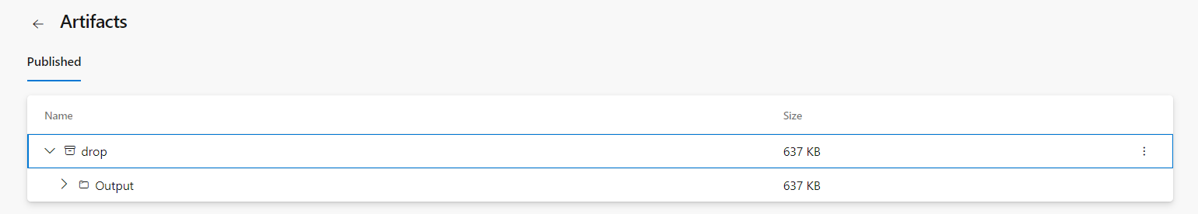

# Revision History

|  |  |  |  |
| --- | --- | --- | --- |
| **Date** | **Version** | **Description** | **Author** |
| **16/5/2023** | 1.0 | **Draft and Initial** | **Atul Sikarwal** |